SPECIFICATION
Part Number: L.SLQ003
Part Description: Artwork, Label, 2-way ClearTract 16 Fr x 10 ml Catheter, Pouch

Purpose

This document provides the artwork specification for the 2-way ClearTract 16 Fr x 10 ml Catheter, Pouch Label (L.SLQ003).

The final label artwork is maintained by Pathway as part of the overall device master record for the 2-way ClearTract 16 Fr x 10 mL Catheter (reference Pathway part number SLQ-LB-4000).

Changes to the content of the label will be approved through Silq’s Document Control process. Once approved internally, Pathway is notified of the changes and will update the final label accordingly.

Supplier

Pathway LLC, 8779 Cottonwood Ave., Suite 105, Santee, CA 92071, Tel: (619) 415-0103.

Specification

Artwork Specification

Pathway Part Number: SLQ-LB-4000

Part Description: Artwork, Label, Pouch, SILQ 2-Way ClearTract Catheter

Label Artwork

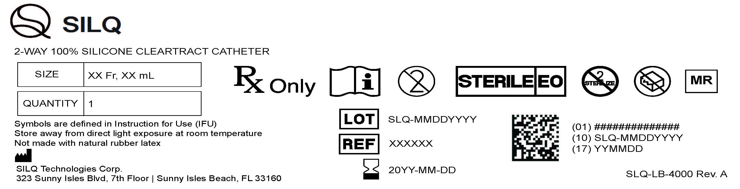

Attachments

SLQ-AW-4000_A.pdf (Pathway)

